**MEXICO MyJNH Portal – myjnh.mx**

* **HOME**
  + - Banner is OK – No Slider Required on the Home Banner
    - Home Page “**Big Buttons**” to display
      * **Clinic Appointment**
      * **Telemedicine Appointment**
      * **Health Risk Assessment**
      * **My Health Documents**
      * **Add People to My Network**
      * **Manage Alerts**
      * **User Profile**
      * **My Appointments**
    - Download Mobile App: Show **COMING SOON**!

* **Home**
* **MyJNH Account**
* **Book An Appointment**
* **Our Locations**
* **Our Services**
* **Support – Same design as Canadian version**

**MyJNH Account**

* Video Visit – HIDE the Live Translator on the right (keep NOTES)
* Live Translator – HIDE this for the MEXICO site as this is too expensive for them.

**Book An Appointment**

* **STEP 1 – No Change**

* **STEP 2**

**ONLY** need **MEDICAL** for Mexico. Hide the other services and only show Medical and have the user enter a REASON for the appointment.

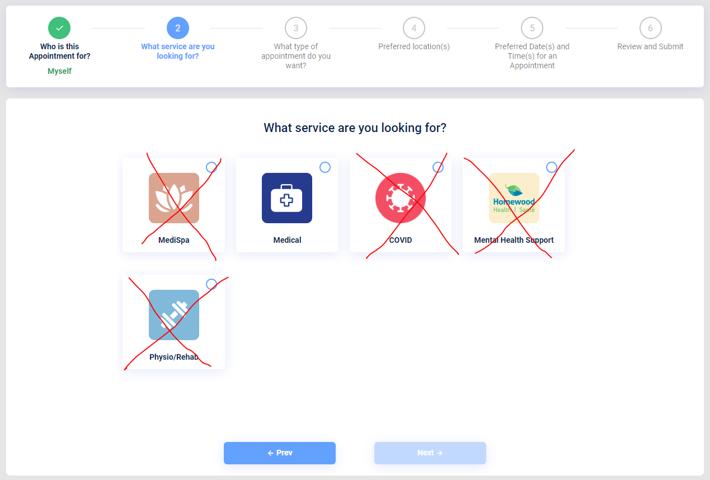

* **STEP 3**
  + - ONLY show **Video** and **Onsite Visit**
    - User can ONLY select 1 option presented to them.
    - Remove FIRST AVAILABLE
    - Remove PHONE

* **STEP 4 – VIDEO (Preferred Provider)**
  + - * REMOVE “**Select a Service**” section on the left, only show the doctors.
      * In Mexico they DO NOT have a family doctor, so only show a list of the doctors and do not group them, only show the doctor profiles for the user to select. Only 1 doctor can be selected.
      * Show the following information for each doctor
        + NAME
        + PICTURE
        + **SHORT Biography** (add to the Doctor Profile).

* **STEP 4 – ONSITE VISIT**
  + - Show the locations and each of the location details.
    - Can you show **clinic hours** using **ONE ROW**.
* **STEP 5 – VIDEO**

This section is OK.

Lets decrease the number of timeslots displayed so it is easier for the user to see.

**IDEA**: **FIRST** **TIMESLOT** on each day should be the earliest timeslot that the doctor is available for that week and the **LAST TIMESLOT** shown should be the latest timeslot that the doctor has for that week.

* **STEP 5 – ONSITE VISIT**

Keep this the same, where the user selects morning, afternoon or evening, but we may need to adjust the times for morning / afternoon / evening.

* **STEP 6 – VIDEO**
  + - Cost for all appointments is $50 Mexican Pesos

**Telemedicine Fee Code** – Format is <####>-<##########>

* + - * User needs to be able to enter a “**Telemedicine Fee Code**”.
      * If the “Telemedicine Fee Code” is **valid** then the Fee is $0 Pesos
      * If the “Telemedicine Fee Code” is **not valid** the fee $50 Pesos.

**Employee ID** – Format is being reviewed and I will get this to you.

* + - * User needs to be able to enter an “Employee ID” code.
      * If the “Employee ID” is valid then the Fee is $0 Pesos
      * If the “Employee ID” is not valid the fee is the full price $50 Pesos.
    - Send patient an Email and Text Message to Confirm Appointment.

**NOTE: Can we integrate STRIPE? I will create a STRIPE account, but for now we are OK to use PAYPAL but will need to offer a STRIPE option to Mexican patients.**

* **STEP 6 – ONSITE**
  + - * No charge
      * Send patient an Email and Text Message to Confirm Appointment.